


© University of Stavanger, 2024. All Rights Reserved.

Forus Media
Summary
Forus Media is an editorial video production and online video streaming business. It provides professionally produced videos in genres including news, entertainment, education and more to subscribers. Forus Media has one main office and 2 branch offices. They have different production facilities that support both production and editing of videos.
The network has to support collaboration between team members that produce and edit videos and upload and download footage to and from the Archive server. The network should also provide streaming of produced videos from the video streaming server out to consumers on the Internet through a web interface.
Table of Contents
Submission Instructions 2
Group Details 2
Implemented Modules 2
Network Topology Screenshot 3
Addressing Table 3
Introduction 4
Requirements Analysis 4
Network Design Overview 4
Network Topology Description 4
Chosen Modules 4
Switch 4
WLAN 5
OSPF 5
ACLs 5
Design Rationale 5
Network Cost 5
Design Challenges and Solutions 6
Appendix 6
Device Configurations (Optional) 6
Router Configuration(s) 6
Switch Configuration(s) 9

List of Tables
Table 1. Group number, student name, number, and email 2
Table 2. Modules and learned concepts implemented 2
Table 3. Screenshot of Network Topology 3
Table 4. Network Devices and their Interface Configuration(s) 3

Submission Instructions
- Following these instructions is mandatory for the lab assignment approval.
- Zip this report together with the project packet tracer file and upload the compressed file to Canvas.

Group Details
- Insert your group number, name, and student number in Table 1.
Group number | Student Name | UiS Student ID | UiS Email
07 | Joar, Wathne | 220476 | jo.wathne@stud.uis.no
07 | Sven Ivar, Søyland | 952138 | si.soyland@stud.uis.no
Table 1. Group number, student name, number, and email

Implemented Modules
- List implemented modules and their associated concepts in Table 3.
Modules | Concepts | Concepts Implemented?
Switch | Configuring basic switch settings. | ☒
Switch | Configuring an EtherChannel with Cisco PAgP or IEEE 802.3ad LACP. | ☒
Switch | Configuring a Redundant EtherChannel Link. | ☒
Switch | Securing trunks, unused switchports, and implementing port security. | ☒
Switch | Enabling DHCP Snooping. | ☐
Switch | Enabling PortFast and BPDU Guard. | ☐
WLAN | Connecting and configuring the wireless router. | ☒
WLAN | Connecting a wired and wireless device to the wireless router and extending the wireless coverage. | ☒
WLAN | Connecting to a wireless LAN controller GUI and configuring a WLAN on a wireless LAN controller. | ☒
WLAN | Configuring a new WLAN on a WLC. | ☒
WLAN | Securing a WLAN with WPA2-Enterprise. | ☐
Single Area OSPF | Configuring OSPF router ID and networks for OSPF routing with or without passive interfaces and verifying OSPF configuration. | ☒
Single Area OSPF | Verifying the connectivity by modifying OSPF default settings and by propagating a default route. | ☒
Single Area OSPF | Identifying and verifying the status of OSPF neighbors. | ☒
Single Area OSPF | Adding a new LAN into an existing OSPF network and verifying connectivity. | ☐
ACLs | Verifying and testing local connectivity with and without ACL. | ☒
ACLs | Configuring, applying, verifying, and modifying a named and numbered standard ACL. | ☐
ACLs | Configuring, applying, and verifying an extended named and numbered ACL. | ☒
ACLs | Configuring IPv4 and IPv6 static and floating static routes, host routes, and routes to the internal LANs. | ☐
ACLs | Configure IPv4 and IPv6 default routes. | ☐
Table 2. Modules and learned concepts implemented

Passwords on Routers and Switches
All passwords are set to “asdf”.

Network Topology Screenshot
- Provide a screenshot of network topology (including IP addresses)
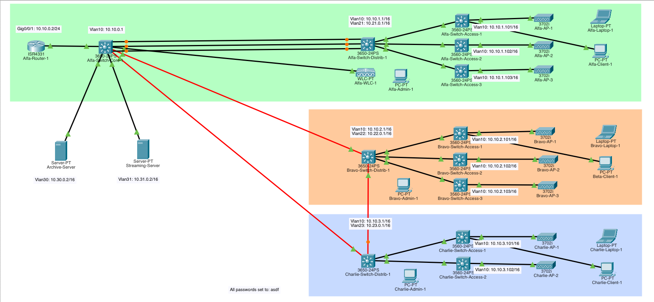
Table 3. Screenshot of Network Topology

Addressing Table
- Describes the types of devices, their interfaces, and associated network configurations.
Device | Interface | IPv4 Address | Subnet Mask | Default Gateway | IPv6 Address
Alfa-Router-1 | Gig0/0/1 | 10.0.0.1 | 255.255.255.0
Alfa-Switch-Core-1 | Vlan10 | 10.10.0.1 | 255.255.0.0 | 10.0.0.1
Alfa-Switch-Distrib-1 | Vlan10 | 10.10.1.1 | 255.255.0.0 | 10.0.0.1
Alfa-Switch-Distrib-1 | Vlan21 | 10.21.0.1 | 255.255.0.0 | 10.0.0.1
Alfa-Switch-Access-1 | Vlan10 | 10.10.1.101 | 255.255.0.0 | 10.0.0.1
Alfa-Switch-Access-2 | Vlan10 | 10.10.1.102 | 255.255.0.0 | 10.0.0.1
Alfa-Switch-Access-3 | Vlan10 | 10.10.1.103 | 255.255.0.0 | 10.0.0.1
Alfa-WLC-1 | Gig0
Alfa-AP-1 | Gig0
Alfa-AP-2 | Gig0
Alfa-AP-3 | Gig0
Alfa-Admin-1 | Fa0 |  |  | 10.0.0.1
Alfa-Laptop-1 | Wireless0 |  |  | 10.0.0.1
Bravo-Switch-Distrib-1 | Vlan10 | 10.10.2.1 | 255.255.0.0 | 10.0.0.1
Bravo-Switch-Distrib-1 | Vlan22 | 10.22.0.1 | 255.255.0.0 | 10.0.0.1
Bravo-Switch-Access-1 | Vlan10 | 10.10.2.101 | 255.255.0.0 | 10.0.0.1
Bravo-Switch-Access-2 | Vlan10 | 10.10.2.102 | 255.255.0.0 | 10.0.0.1
Bravo-Switch-Access-3 | Vlan10 | 10.10.2.103 | 255.255.0.0 | 10.0.0.1
Bravo-AP-1 | Gig0
Bravo-AP-2 | Gig0
Bravo-AP-3 | Gig0
Bravo-Admin-1 | Fa0 |  |  | 10.0.0.1
Bravo-Laptop-1 | Wireless0 |  |  | 10.0.0.1
Charlie-Switch-Distrib-1 | Vlan10 | 10.10.3.1 | 255.255.0.0 | 10.0.0.1
Charlie-Switch-Distrib-1 | Vlan23 | 10.23.0.1 | 255.255.0.0 | 10.0.0.1
Charlie-Switch-Access-1 | Vlan10 | 10.10.3.101 | 255.255.0.0 | 10.0.0.1
Charlie-Switch-Access-2 | Vlan10 | 10.10.3.102 | 255.255.0.0 | 10.0.0.1
Charlie-AP-1
Charlie-AP-2
Charlie-Admin-1 | Fa0 |  |  | 10.0.0.1
Charlie-Laptop-1 | Wireless0 |  |  | 10.0.0.1
Archive-Server | Vlan30 | 10.30.0.1 | 255.255.0.0 | 10.0.0.1
Streaming-Server | Vlan31 | 10.31.0.1 | 255.255.0.0 | 10.0.0.1
Table 4. Network Devices and their Interface Configuration(s)

Introduction
- Provide a brief introduction (1-2 paragraphs) explaining the purpose of your network design and its objectives.
- The network will support the video production and streaming business Forus-Media. Here several teams will produce videos on various topics in different studios and then edit the videos on workstations across the buildings.
- The network will allow streaming of finished videos from the Streaming server to consumers on the Internet.

Requirements Analysis
- What is the requirement of the network you will design.
- Summarize the answers and how they influenced your design decisions.
- The wired network would need to have relatively high bandwidth to support the transfer of large video files.
- The streaming and archive server needs a high bandwidth connection.
- The users needs to have access to one or more wireless networks that works across all the buildings so that they can seamlessly use the different facilities during their work.
- As the production teams work they might want to have their own separate VLAN and they might want to move around the buildings to use the different facilities.
- Summary: The network needs to have a high capacity and needs to be scalable to account for more viewers. It should be possible to create a separate VLAN for a team, if needed.
The network uses high bandwidth switches to provide the required bandwidth where EtherChannel configurations can provide link scalability. The layer 3 switches support inter VLAN routing and simplifies the network design. VLANs are propagated in the network with VTP. Security and confidentiality is ensured by implementing ACLs, disabling unused switch ports and implementing port security.

Network Design Overview

Network Topology Description
- Describe the physical and logical topology of your network design.
- Explain why you chose a particular topology.
- The distribution switches and the core switch are physically connected in a mesh topology to provide redundancy for the part of the network that sees the highest load and could otherwise potentially become a single point of failure.
- Each group of access switches are physically connected to the corresponding distribution switch in a simple spoke and wheel topology.
- Logically the network is divided into different VLANs, separating the management network and different buildings and potentially different working group networks from eachother to ensure security and reliability.

Chosen Modules
- List and describe the three modules from Table 2 that you chose to implement.

Switch
- Configuring basic switch settings
  - We have configured …
- Configuring an EtherChannel with Cisco PAgP or IEEE 802.3ad LACP
  - An EtherChannel has been configured …
- Configuring a Redundant EtherChannel Link.

- Securing trunks, unused switchports, and implementing port security.

WLAN
- Connecting and configuring the wireless router.

- Connecting a wired and wireless device to the wireless router and extending the wireless coverage.

- Connecting to a wireless LAN controller GUI and configuring a WLAN on a wireless LAN controller.

- Configuring a new WLAN on a WLC.

ACLs
- Verifying and testing local connectivity with and without ACL.

- Configuring, applying, verifying, and modifying a named and numbered standard ACL.

- Configuring, applying, and verifying an extended named and numbered ACL.

- Configuring IPv4 and IPv6 static and floating static routes, host routes, and routes to the internal LANs.

- Configure IPv4 and IPv6 default routes.

Design Rationale
- Explain why you chose these modules and what problems or scenarios do they address?
- The layer 3 switches provide a simple and cost effective way to separate the different networks and provide routing between them.
- The wireless networks allows the video production teams to seamlessly move between the buildings. The network administrators can also use their own wireless network to administrate devices.
- ACLs provides security and stability by restricting access to networks for certain devices or networks. The video production groups can work with confidential content and use local file sharing without worrying about eavesdropping. The management of the network equipment can safely be done over its own VLAN.

Network Cost
- What is the approximate cost of your designed network?
Device Category | Device | Cost (in NOK) | Cost Reference (per-device)
Core Network Components | Cisco 4331 (routers) | 1 x 36.842,00 Kr | https://www.atea.no/eshop/product/cisco-integrated-services-router-4331-ruter-rackmonterbar/?prodid=3104396
Core Network Components | Cisco 3650 (switches) | 4 x 71.632,00 Kr | https://www.prisjakt.no/product.php?p=2300423
Core Network Components | Cisco 3560 (switches) | 8 x 20.990,00 Kr | https://www.prisjakt.no/product.php?p=3124260
Core Network Components | Cisco 3504 WLC | 1 x 16.513,00 kr | https://www.networkhardwares.com/en-no/products/cisco-air-ct3504-k9-cisco-3504-ieee-802-11ac-wireless-lan-controller-air-ct3504-k9?variant=47451653177549&srsltid=AfmBOorRhS-p6y3bWN9gwU661biUwfuMR-VeDxuD4IQVPi-2oRJNhvIbuNU
Core Network Components | Cisco C9120AXIB | 8 x 13.819,00 kr | https://www.networkhardwares.com/en-no/products/cisco-c9120axib-cisco-catalyst-9120ax-series-c9120axib
End Devices | Servers | 2 x 86.713,00 Kr | https://www.atea.no/eshop/product/hpe-proliant-dl360-gen10-smb-network-choice-rackmonterbar-xeon-silver-4208-2-1-ghz-16-gb-uten-hdd/?prodid=4188988
End Devices | PCs | 3 x 8.000,00 Kr | -
End Devices | Laptops | 3 x 16.000,00 Kr | -
 | Total | 863.781,00 Kr
 | Table 5. Network Devices and their Interface Configuration(s)

Design Challenges and Solutions
- Describe any potential issues faced during the network design.

Appendix

Device Configurations (Optional)

Router Configuration(s)
- Provide the full text of the exported configurations for all routers used in your design. Include all relevant settings, such as interfaces, routing protocols, and security settings.
- An example has been done for you in the table below:

Alfa-Router-1
!

Switch Configuration(s)
- Provide the full text of the exported configurations for all switches used in your design. Include all relevant settings, such as VLANs, port security, and EtherChannel configurations.
- An example has been done for you in the table below:
Alfa-Switch-Core-1
!

Alfa-Switch-Distrib-1
!

Alfa-Switch-Access-1
!

Alfa-Switch-Access-2
!

Alfa-Switch-Access-3
!

Bravo-Switch-Distrib-1
!

Bravo-Switch-Access-1
!

Bravo-Switch-Access-2
!

Bravo-Switch-Access-3
!

Charlie-Switch-Distrib-1
!

Charlie-Switch-Access-1
!

Charlie-Switch-Access-2
!

Charlie-Switch-Access-3
!

